Smith, Amanda
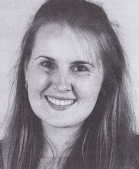
Graduated as a field officer in 1996, having completed the 14 weeks competency based training course. Her father, Ray Smith, was a wildlife officer. Grew up in Albany. Completed high school at Bunbury Cathedral Grammar School. Graduated with BSc in Enviromental Science from Murdoch University in 1995. Appointed to CALM Forest Management Branch Bunbury in 1996. Involved in mapping and inventory. Appointed assistant area coordinator with Lower West Sharefarms at Collie in 1997. Appointed as a catchment recovery officer in Wheatbelt Region in 1998. Involved in management of Toolibin Lake nature reserve.

